Cognitive Attention Monitoring Using
Brain–Computer Interface

R. Sravanth Kumar  Department of AI  Anurag University  Hyderabad, India  sravanthkumar.ai@anurag.edu.in | I.Pooja Sindhura Reddy  Department of AI  Anurag University  Hyderabad, India  22eg106a19@anurag.edu.in | M.Revanth  Department of AI  Anurag University  Hyderabad, India  22eg106a35@anurag.edu.in | K.Venkat Sai  Department of AI  Anurag University  Hyderabad, India  Poshwanthvenkatsai.kunireddy@gmail.com

Abstract - Performance of a task and learning rate of people is primarily dependent on 'Attention', we may loose our attention in between a task and we are unaware of it. Electroencephalogram (EEG) signals help you to observe brain activity in a direct and non-invasive way and have been widely used for analysing cognitive states such as attention. The motivation behind this work is the growing need for an objective and accessible method to monitor attention which is of affordable cost, especially in academic and work environments where loss of focus can significantly reduce productivity. Although existing studies have reported promising results using EEG-based attention detection with deep learning and transformer models, many rely on wearable devices, complex experimental setups, or high computational resources, which limit their accessibility and practical adoption. Furthermore, several approaches focus mainly on offline analysis, lack model simplicity, or show limited generalization across different datasets. To overcome these challenges, this paper presents a software-based EEG attention monitoring system using publicly available EEG datasets, without the need for physical data acquisition devices. It involves preprocessing signals, extracting features related to attention, and classifying mental states into focused and distracted categories using ML or DL techniques. Experimental evaluation using standard performance metrics shows the effectiveness of the proposed framework, while also providing a scalable and cost-effective foundation for future real-time attention monitoring systems.

Keywords—Electroencephalogram (EEG), Attention Monitoring, Brain–Computer Interface (BCI), Cognitive State Classification

Introduction

Attention is a crucial skill that helps in the processing of information. Processing details while performing a task, understanding written text, and recalling a particular term all require attention. Sarter et al. (2001) defined sustained attention as a fundamental component of attention characterized by a readiness to detect rarely and unpredictably occurring signals over prolonged periods. Consequently, an individual needs to possess sustained attention. Unfortunately, most existing techniques for assessing an individual's attention today are based on surveys and questionnaires to understand an individual's attention state. However, this method is unreliable because respondents may interpret certain responses differently, resulting in ambiguous data. One of the most reliable techniques for decoding brain activity is reconstructing stimuli or brain states from data collected using various methods such as an electroencephalogram (EEG) or functional magnetic resonance imaging (fMRI). So, to build a powerful and accurate system that detects and improves the level of attention in real-time, we have proposed a deep learning model combined with Grid Search. Grid Search is used in parallel to build a robust model that can handle a large dataset and correctly identify system users. EEG signals are used in the proposed model to record electrical signals that indicate brain activity and responses. [1] . Attention is a fundamental mechanism in human cognition, involving the selective allocation of mental resources to a specific task while suppressing irrelevant information. It plays a crucial role in various contexts, such as learning, work, driving, and human-computer interaction. For example, students' attention levels directly affect learning performance, and driver distraction may lead to accidents. Therefore, accurately identifying an individual's attention state is essential for improving effectiveness and ensuring safety. Electroencephalogram (EEG) signals have become an effective tool for assessing attention states due to their high temporal resolution and non-invasiveness. Brain-Computer Interface (BCI) technology serves as a bridge connecting the brain to external devices and is classified into invasive and non-invasive types. In recent years, BCI has been widely applied in fields such as emotion recognition, biometric identification, and attention detection, demonstrating promising potential. Attention is an essential cognitive function primarily associated with frontal and parietal regions, both of which play a central role in maintaining sustained attention. Different EEG frequency bands (e.g., Delta, Theta, Alpha, Beta, Gamma) reflect brain activity changes under various physiological and cognitive states. In recent years, researchers have proposed various EEG-based attention recognition methods. [2]
Attention is a cognitive process of the human brain that is closely related to many other functions, such as emotion, memory and decision-making. Attention regulation refers to the ability of individuals to maintain and modulate their attention to respond to different scenarios. In our daily lives, maintaining an appropriate level of attention plays an important role in protecting mental health and improving work efficiency. However, the prevalence of attention disorders is increasing annually, and individuals with difficulties in attention regulation face a greater risk of mental disorders. In addition, most existing studies have focused on attention recognition, and the neural mechanism of attention regulation needs further exploration. Therefore, developing an effective way to improve people’s attention regulation ability is highly important. Compared with the traditional attention recognition methods based on behavioral assessments, facial expressions and eye movements, electroencephalography (EEG) is considered the gold standard for attention recognition because it directly reflects the activity of the central nervous system. With the goals of evaluating and enhancing attention, EEG-based brain-computer interfaces (BCIs) for attention recognition have achieved preliminary results. In summary, most of the previous studies have focused on offline recognition of attention states, with limited studies on BCI systems designed for online attention detection and regulation. Despite the preliminary positive results achieved by existing research on attention regulation BCI systems, further improvement is needed in the following areas. [3] Attention is a crucial skill that helps in the processing of information.Processing details while performing a task, understanding written text, and recalling a particular term all require attention.Sarter et al. (2001) defined sustained attention as a fundamental component of attention characterized by a readiness to detect rarely and unpredictably occurring signals over prolonged periods.Consequently, an individual needs to possess sustained attention.Unfortunately, most existing techniques for assessing an individual's attention today are based on surveys and questionnaires to understand an individual's attention state.However, this method is unreliable because respondents may interpret certain responses differently, resulting in ambiguous data.One of the most reliable techniques for decoding brain activity is reconstructing stimuli or brain states from data collected using various methods such as an electroencephalogram (EEG) or functional magnetic resonance imaging (fMRI). [4] Attention is a fundamental mechanism in human cognition, involving the selective allocation of mental resources to a specific task while suppressing irrelevant information.It plays a crucial role in various contexts, such as learning, work, driving, and human-computer interaction.For example, students' attention levels directly affect learning performance, and driver distraction may lead to accidents.Therefore, accurately identifying an individual's attention state is essential for improving effectiveness and ensuring safety.Electroencephalogram (EEG) signals have become an effective tool for assessing attention states due to their high temporal resolution and non-invasiveness.Brain-Computer Interface (BCI) technology serves as a bridge connecting the brain to external devices and is classified into invasive and non-invasive types.In recent years, BCI has been widely applied in fields such as emotion recognition, biometric identification, and attention detection, demonstrating promising potential. [5]
Attention is a cognitive process of the human brain that is closely related to many other functions, such as emotion, memory and decision-making.Attention regulation refers to the ability of individuals to maintain and modulate their attention to respond to different scenarios.In our daily lives, maintaining an appropriate level of attention plays an important role in protecting mental health and improving work efficiency.However, the prevalence of attention disorders is increasing annually, and individuals with difficulties in attention regulation face a greater risk of mental disorders.Compared with the traditional attention recognition methods based on behavioral assessments, facial expressions and eye movements, electroencephalography (EEG) is considered the gold standard for attention recognition because it directly reflects the activity of the central nervous system.With the goals of evaluating and enhancing attention, EEG-based brain-computer interfaces (BCIs) for attention recognition have achieved preliminary results. [6] So, to build a powerful and accurate system that detects and improves the level of attention in real-time, we have proposed a deep learning model combined with Grid Search.Grid Search is used in parallel to build a robust model that can handle a large dataset and correctly identify system users.EEG signals are used in the proposed model to record electrical signals that indicate brain activity and responses.Attention is an essential cognitive function primarily associated with frontal and parietal regions, both of which play a central role in maintaining sustained attention.Different EEG frequency bands (e.g., Delta, Theta, Alpha, Beta, Gamma) reflect brain activity changes under various physiological and cognitive states, and are closely related to higher-level functions such as emotion regulation and attention maintenance.Over the past few decades, many studies have focused on exploring the underlying neural mechanisms and pathology of related diseases in humans.With the goals of evaluating and enhancing attention, EEG-based brain-computer interfaces (BCIs) for attention recognition have achieved preliminary results.In their experiment, 15-channel EEG signals were recorded from 11 participants.Using power spectral density (PSD) features and a linear discriminant analysis classifier, a maximum offline recognition accuracy of 84.8% was achieved.Using band-power features and a support vector machine (SVM) classifier, they achieved an offline average accuracy of 76.82% with 24 subjects.[7]

Fig1 illustrates the overall workflow of a Brain–Computer Interface (BCI) system. The process begins with signal acquisition, where brain signals such as EEG and fNIRS are collected. These signals undergo signal processing, which includes pre-processing, feature extraction, and classification to interpret brain activity. The processed data is then transmitted through an application interface, enabling control over a real-world application. A feedback loop allows continuous interaction between the user’s brain and the system, improving performance and adaptability.

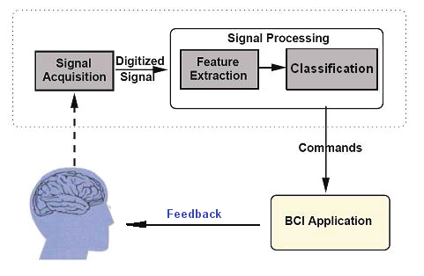
Fig1: Processing of the EEG signal

II. BACKGROUND AND RELATED WORK :

Attention is a fundamental cognitive process that plays a crucial role in learning, decision-making, and task performance. Several studies have emphasized that sustained attention is essential for maintaining focus over extended periods, especially in activities such as driving, studying, and human-computer interaction. Traditional methods for measuring attention, such as questionnaires and behavioral assessments, have been widely used but suffer from subjectivity and inconsistency. As a result, researchers have increasingly turned toward physiological signal analysis, particularly electroencephalography (EEG), which provides a direct and reliable measure of brain activity with high temporal resolution.
Recent advancements in Brain–Computer Interface (BCI) systems have enabled the development of automated attention monitoring solutions using EEG signals. Machine learning approaches such as K-Nearest Neighbors (KNN), Support Vector Machines (SVM), and Random Forest have been applied to classify attention states based on extracted EEG features like alpha and theta band activity. These methods have demonstrated moderate success, achieving reasonable classification accuracy while being relatively simple to implement. However, they often rely on handcrafted features and may struggle to generalize across different subjects and environments, limiting their real-world applicability.
To overcome these limitations, deep learning-based approaches have been proposed, including convolutional neural networks and transformer-based architectures such as the Swin Transformer. These models are capable of automatically extracting complex spatial and temporal features from EEG data, leading to improved classification accuracy and robustness. Additionally, wearable EEG devices and neurofeedback-based BCI systems have been introduced to enable real-time attention monitoring and regulation. These systems provide continuous feedback to users, helping them improve their focus over time. Despite these advancements, many existing solutions rely on expensive equipment, complex architectures, or offline analysis, which restricts their usability in practical scenarios.
Although significant progress has been made in EEG-based attention detection, several challenges remain. Most existing studies focus primarily on attention recognition rather than real-time monitoring and improvement. Furthermore, many systems lack portability, scalability, and user-friendly implementation, making them unsuitable for everyday use. There is also a need for models that can efficiently balance accuracy and computational complexity while working with real-time data. These limitations highlight the need for a practical, cost-effective, and real-time attention monitoring system, which motivates the development of the proposed Cognitive Attention Monitoring system using Brain–Computer Interface.
EEG-based attention analysis has gained significant attention due to its ability to capture real-time neural dynamics associated with cognitive states. Researchers have identified that variations in EEG frequency bands such as delta, theta, alpha, beta, and gamma are closely linked to different levels of attention and mental engagement. In particular, increased theta and decreased beta activity have been associated with reduced attention, while alpha band variations are often linked to mind-wandering. These physiological indicators provide a strong foundation for developing automated systems that can detect and interpret attention states with higher accuracy compared to traditional behavioral methods.
Various experimental paradigms have been designed to study attention using EEG signals, including driving simulations, cognitive tasks, and controlled distraction environments. These approaches allow researchers to analyze how attention fluctuates under different conditions and to label datasets accordingly. While such methods improve the reliability of training data, they often require controlled laboratory settings, limiting scalability. Additionally, many studies rely on multi-channel EEG systems, which provide detailed spatial information but increase system complexity, cost, and setup time, making them less practical for real-world deployment.
In terms of system implementation, several studies have explored real-time attention monitoring using BCI frameworks integrated with machine learning and deep learning models. Some systems incorporate neurofeedback mechanisms, where users receive continuous feedback about their attention levels, enabling them to consciously regulate their focus. These approaches have shown promising results in improving cognitive performance and attention control. However, challenges remain in ensuring stable real-time performance, reducing noise and artifacts in EEG signals, and maintaining consistent accuracy across different users due to inter-subject variability.
Despite the progress in this domain, there is still a lack of lightweight, efficient, and user-friendly systems that can operate reliably in real-world environments. Many existing models prioritize accuracy but overlook computational efficiency and deployment feasibility. Furthermore, limited attention has been given to multi-class classification of attention states (such as focused, neutral, and distracted), which is more realistic than binary classification. Addressing these gaps requires the development of a system that combines effective signal processing, robust machine learning techniques, and practical usability, thereby enabling continuous attention monitoring and enhancement in everyday scenarios.

III. DATA ACQUISITION AND PREPROCESSING :

The performance of any EEG-based Brain–Computer Interface (BCI) system highly depends on the quality of the acquired signals and the effectiveness of preprocessing techniques. In this study, EEG data is obtained from a publicly available dataset consisting of multi-channel brain signal recordings collected under controlled experimental conditions. The dataset includes signals corresponding to different cognitive states, enabling the classification of attention levels such as focused, neutral, and distracted. EEG signals are recorded using standard electrode placement based on the international 10–20 system, ensuring consistent spatial coverage of brain regions associated with attention, particularly the frontal and parietal lobes.
The raw EEG signals are inherently noisy and susceptible to various artifacts, including eye blinks, muscle movements, and environmental interference. Therefore, a comprehensive preprocessing pipeline is applied to enhance signal quality. Initially, band-pass filtering is performed within the frequency range of 0.5 Hz to 50 Hz to remove low-frequency drift and high-frequency noise. This step ensures that only relevant brain signal components associated with cognitive activity are retained. Additionally, power line noise is minimized using notch filtering where necessary.
To further improve signal reliability, artifact removal techniques are employed. Independent Component Analysis (ICA) is used to separate and eliminate non-neural components such as ocular and muscular artifacts. Channels exhibiting abnormal patterns or excessive noise are either corrected using interpolation or excluded from further analysis. After artifact removal, the continuous EEG signals are segmented into smaller time windows (epochs) based on task-related events or fixed intervals. This segmentation facilitates efficient feature extraction and model training.
Following preprocessing, feature extraction is performed to convert EEG signals into meaningful representations. The signals are transformed from the time domain to the frequency domain using Fast Fourier Transform (FFT) or Power Spectral Density (PSD) analysis. Key features are derived from standard EEG frequency bands, including delta, theta, alpha, beta, and gamma. These features capture variations in brain activity associated with different attention states. The processed and feature-engineered dataset is then normalized to ensure consistency and is used as input for subsequent machine learning and classification models.

IV. FEATURE EXTRACTION

Extracting the important features plays a critical role in transforming preprocessed EEG signals into meaningful representations that can be effectively used for classification. Since raw EEG data is high-dimensional and complex, extracting relevant features helps in reducing data redundancy while preserving essential information related to cognitive states. In this work, both time-domain and frequency-domain characteristics are considered to capture variations in brain activity associated with different attention levels. The segmentation of EEG signals into fixed-length epochs enables consistent feature computation across all samples.
To analyze the spectral characteristics of EEG signals, frequency-domain transformation techniques such as Fast Fourier Transform (FFT) and Power Spectral Density (PSD) are employed. These methods convert time-series EEG signals into their corresponding frequency components, allowing the identification of dominant brain wave patterns. Features are extracted from standard EEG frequency bands, namely delta (1–4 Hz), theta (4–8 Hz), alpha (8–13 Hz), beta (13–30 Hz), and gamma (above 30 Hz). Variations in these bands are strongly correlated with cognitive processes; for instance, theta and alpha bands are commonly associated with attention and mental workload, while beta activity reflects active concentration.
In addition to spectral features, spatial and statistical features are also considered to enhance classification performance. EEG signals from different brain regions, particularly frontal and parietal areas, are analyzed to capture region-specific activity patterns. Statistical measures such as mean, variance, and band power are computed for each frequency band to quantify signal characteristics. These extracted features are then combined into a feature vector representing each EEG segment. Finally, feature normalization is applied to ensure uniform scaling, which improves the efficiency and accuracy of machine learning models used for attention state classification.

V. Data Preprocessing and Feature Extraction Methodology:

System Architecture:

The proposed system follows a structured pipeline for detecting and classifying attention levels using EEG signals. Initially, EEG data is collected from a publicly available dataset, which contains brain signal recordings corresponding to different cognitive states. This dataset serves as the foundation for training and evaluating the model. The collected raw signals are then passed through a signal preprocessing stage, where noise, artifacts, and irrelevant frequency components are removed using filtering and artifact removal techniques to improve data quality.

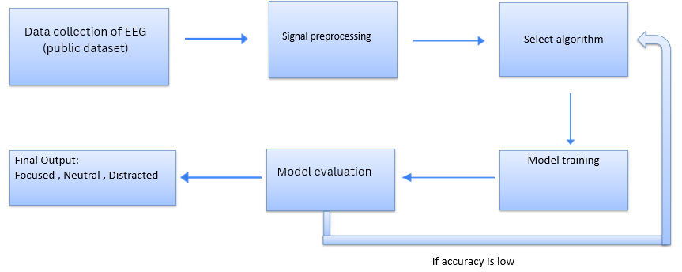

Fig 2: Methodology diagram

Algorithmic Design :

Core ensemble model —Random Forest (RF) form the foundation of the classification module.

Random Forest (RF)

Random Forest constructs an ensemble of decision trees, where each tree is trained on random subsets of the training data and features. The final prediction is obtained through majority voting across all trees.

Mathematically, given a dataset

$$D=\{(x_{i},y_{i})\}_{i=1}^{N}$$

each decision tree $T_{m}$produces a prediction $T_{m}(x)$. The final output of the ensemble is defined as:

$$\begin{matrix} & \hat{y}=\text{mode}\{T_{1}(x),T_{2}(x),…,T_{M}(x)\} & & \text{(1)}\end{matrix}$$

where $M$denotes the total number of decision trees in the forest.

Random Forest reduces overfitting by introducing randomness through bootstrap sampling (bagging) and feature selection at each split, which decorrelates individual trees. This results in improved generalization performance and robustness, making it particularly suitable for handling noisy and high-dimensional biomedical data such as EEG signals.

It is employed as the core classification algorithm in the proposed system due to its robustness and high accuracy in handling complex and noisy data such as EEG signals. It operates by constructing an ensemble of decision trees, where each tree is trained on randomly selected subsets of the data and features, thereby introducing diversity among the models. For a given input feature vector (x), each tree (T_m) produces a prediction, and the final output is determined using majority voting, expressed as (\hat{y} = \text{mode} {T_1(x), T_2(x), \dots, T_M(x)}). This ensemble approach reduces overfitting through bootstrap aggregation (bagging) and feature randomness, leading to improved generalization performance. As a result, Random Forest is particularly well-suited for EEG-based attention classification, where data variability and noise are significant challenges.

Data Preprocessing:

Data preprocessing is a crucial step in the proposed system to ensure the quality and reliability of EEG data before model training. Initially, the dataset is loaded and relevant features corresponding to EEG frequency bands (delta, theta, alpha, beta, and gamma) are selected, while the target labels representing attention states are extracted. Since machine learning models require numerical inputs, categorical labels are converted into numeric form using Label Encoding. The dataset is then divided into training and testing sets using a standard split ratio to evaluate model performance effectively. To handle variations in feature scales, Standardization is applied using a Standard Scaler, which transforms the data to have zero mean and unit variance. This step ensures that all features contribute equally to the model and improves overall performance. The same scaling parameters are applied to both training and testing data to maintain consistency, resulting in a clean, normalized dataset ready for accurate classification.

Feature Extraction:
Feature extraction in the proposed system focuses on utilizing meaningful EEG frequency band information to represent the user’s cognitive state effectively. Instead of working with raw EEG signals, the dataset already provides precomputed band power values corresponding to delta, theta, alpha, beta, and gamma waves, which reflect different brain activities. These frequency-domain features are directly selected and used as input to the model, as they are strongly correlated with attention levels and mental engagement. By using these band-specific values, the system captures essential patterns in brain activity without requiring complex signal transformation techniques. This approach reduces computational complexity while retaining the most relevant information needed for classification, enabling the model to efficiently distinguish between focused, neutral, and distracted states.

In addition to selecting EEG band power features, the feature extraction process ensures that the data is structured in a way that enhances the model’s learning capability. Each EEG sample is represented as a feature vector consisting of the five frequency bands, allowing consistent input across all observations. This structured representation simplifies pattern recognition for the classifier and helps in capturing variations in attention levels effectively. Furthermore, by focusing on these domain-relevant features, the system avoids unnecessary dimensionality and noise that may arise from raw signal processing. This streamlined feature extraction approach not only improves computational efficiency but also contributes to better classification performance and model generalization.

VI. RESULTS AND DISCUSSION

📊 Classification Report:

Fig 2 the classification report shows, the model shows a high overall Accuracy of 94%, but a closer look at the metrics reveals a significant struggle with the "Focused" class. While the model is perfect at identifying the "Neutral" state and performs well on "Distracted," it suffers from a major class imbalance. Specifically, for the "Focused" category, it has a Recall of only 0.01, meaning it failed to identify almost all focused individuals, likely misclassifying them as "Distracted." This performance gap is highlighted by the Macro Average F1-score (0.65), which is much lower than the accuracy, signaling that the model is biased toward the majority classes and is not yet reliable for detecting the minority "Focused" state.

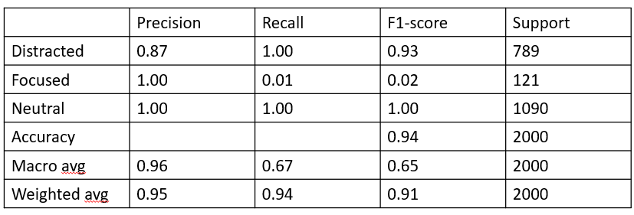

Fig 2 : Report on the classification

Fig 3 Shows the comparison shows that Gradient Boosting significantly outperforms Random Forest across every metric. While Random Forest achieves a high accuracy of 94%, its much lower Recall (66.9%) and F1-score (64.9%) indicate it fails to identify a large portion of actual cases. Gradient Boosting, however, maintains near-perfect consistency with an Accuracy of 98% and an F1-score of 98.7%, proving it is the far more robust and reliable model for this dataset.

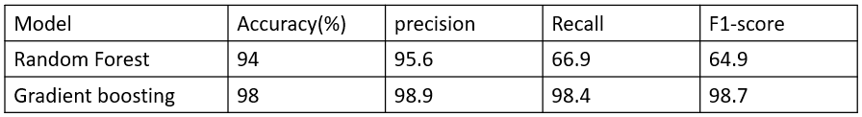
Fig 3: Result Table

Fig 4 This bar chart compares Signal Strength across three mental states: distracted, focused, and neutral. The focused state exhibits the highest signal intensity (just above 0.7), followed closely by the distracted state (approx. 0.69). In contrast, the neutral state shows a noticeably lower signal strength, peaking at roughly 0.46. This suggests that both focused and distracted activities trigger significantly higher levels of engagement or physiological response compared to a neutral baseline.
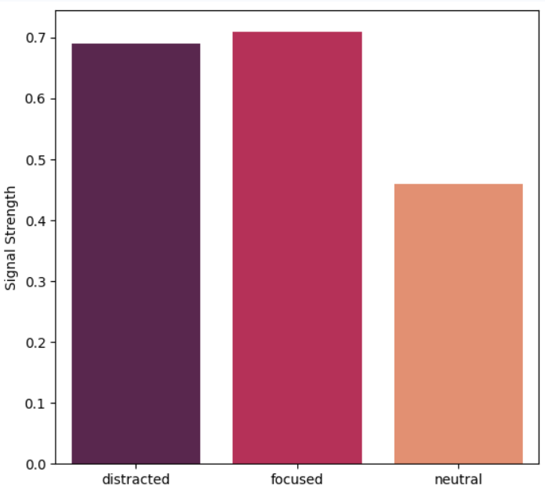

Fig 4:Model Evaluation Metrics – Bar Graph

In Fig 5 This line graph compares the average "Value" for three attention states: distracted, focused, and neutral, showing how the value changes across them. The value is highest when the state is focused, slightly lower when distracted, and drops sharply for the neutral state, indicating that whatever is being measured performs best under focused attention, moderately under distraction, and worst when neutral.

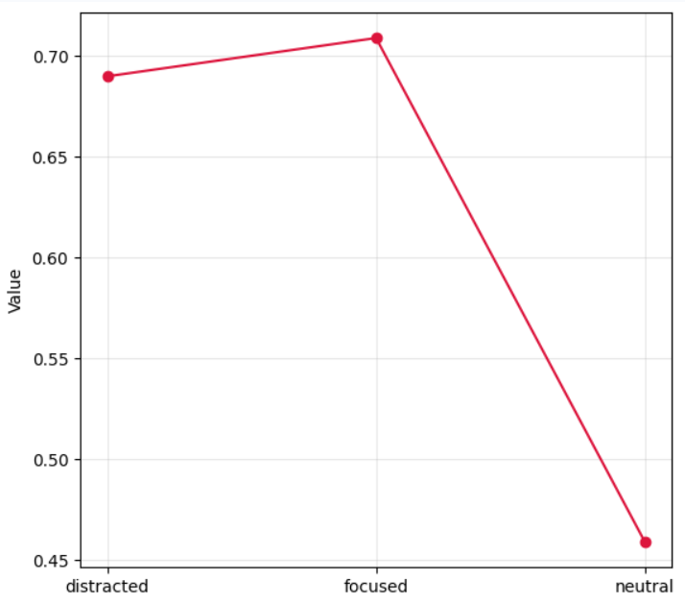

Fig 5:Model Evaluation Metrics – Line Graph

We came to know that Random Forest algorithm is declared as the most successful machine learning model in detecting varying stress levels from EEG data. Especially it is well suited for this task because of its capacity to learn from patterns and make predictions over time. The model showed a high degree of accuracy in the majority of cases and performed well in differentiating between low, moderate, and high stress levels.
Differentiating between neutral and high stress states was one of the model's challenges, though. The reason for this confusion was that the brain wave patterns linked to these two conditions occasionally looked a lot like one another, particularly in particular people or situations. The model's predictions remained highly consistent and reliable in spite of this sporadic overlap.
The accuracy and interpretability of the Gradient Boosting model are what really make it useful. Gradient Boosting makes it simpler for researchers and observers to comprehend and trust the results by pointing the features that contributed the most , in contrast to some intricate black-box models. When using the model in practical situations, this transparency is essential.
It also has important real world applications. For example, it can be used to keep track of student's stress levels during tests or other high-pressure academic activities, so that teachers could take responsibility when necessary. It has potential for use in mental health care as well, as clinicians could use it to monitor patients' stress levels over time and modify treatment regimens as necessary. The Gradient Boosting model makes a significant contribution to the applied and research fields of neuroscience and mental health by providing a trustworthy and intelligible method of evaluating stress.

VII. APPLICATIONS

The proposed Cognitive Attention Monitoring System using EEG-based Brain–Computer Interface has broad and significant real-world applicability across multiple domains, leveraging the system's ability to objectively classify attentional states in real-time as focused, neutral, or distracted.
A. Education and E-Learning
One of the most direct and impactful applications of the proposed system lies in the domain of education, both in traditional classroom environments and modern e-learning platforms. Students' attention levels directly and measurably influence their learning performance and academic outcomes, making real-time attention monitoring a highly valuable tool for educators and learners alike. The proposed system can be seamlessly integrated into existing online learning platforms to continuously track a student's cognitive engagement throughout a lecture or study session, providing both the learner and the instructor with objective, data-driven feedback on attention patterns. When the system detects a sustained distracted state, it can trigger adaptive interventions such as interactive prompts, short breaks, or difficulty adjustments to re-engage the learner, thereby personalizing the educational experience in a manner that static content delivery cannot achieve.
B. Workplace Productivity Monitoring
In professional work environments, lapses in attention and sustained cognitive fatigue are among the leading contributors to reduced productivity, increased error rates, and workplace accidents. The proposed EEG-based attention monitoring system can be deployed as a wearable cognitive assistant for knowledge workers, software developers, researchers, and other professionals engaged in mentally demanding tasks, providing continuous and unobtrusive monitoring of their attentional states throughout the workday. By identifying transitions from a focused to a neutral or distracted state, the system can prompt the user to take timely micro-breaks, adjust their work schedule, or employ cognitive recovery strategies before performance degradation becomes significant.
C. Driver Drowsiness and Distraction Detection
Road safety represents one of the most critical application domains for real-time attention monitoring, as driver inattention and drowsiness are among the leading causes of traffic accidents and fatalities worldwide. The proposed system, which builds upon EEG-based sustained attention detection methodologies validated in driving simulation experiments , can be adapted for integration into intelligent vehicle systems to continuously monitor the driver's cognitive state during operation. When the system detects a transition into a distracted or low-attention state — evidenced by characteristic increases in theta and delta band power and decreases in beta band power across the occipital and temporal regions — it can trigger auditory or haptic alerts to warn the driver, automatically adjust vehicle speed, or initiate handover protocols in semi-autonomous driving systems, thereby significantly reducing the risk of attention-related accidents.
D. Clinical Assessment and Rehabilitation for Attention Disorders
The proposed system holds substantial promise as a clinical tool for the assessment, monitoring, and rehabilitation of individuals diagnosed with attention-related neurological and psychiatric disorders, including Attention Deficit Hyperactivity Disorder (ADHD), Autism Spectrum Disorder (ASD), and mild cognitive impairment associated with dementia or traumatic brain injury. As demonstrated in prior neurofeedback-based BCI studies, long-term attention regulation training through real-time EEG feedback can produce measurable improvements in sustained attention, executive function, and frontal-parietal brain network connectivity.
E. Human–Computer Interaction and Adaptive Systems
The integration of real-time cognitive state monitoring into human–computer interaction (HCI) frameworks represents a transformative step toward the development of truly adaptive and intelligent computing systems. By incorporating the proposed EEG-based attention classification system into the interaction loop, software applications and operating systems can dynamically adjust their behavior, interface complexity, notification delivery, and task demands in response to the detected cognitive state of the user. For instance, a writing or coding application could suppress non-critical notifications and minimize interface distractions when a focused state is detected, while proactively suggesting rest or lighter tasks when a distracted state persists, creating a symbiotic relationship between the user's cognitive capacity and the system's functional demands that maximizes both performance and wellbeing.
F. Sports Performance and Cognitive Training
In the domain of sports science and elite athletic training, maintaining peak cognitive focus during high-pressure performance situations is as important as physical conditioning. The proposed attention monitoring system can be employed as a cognitive training tool for athletes, enabling coaches and sports psychologists to objectively assess an athlete's attentional state during training drills, pre-competition preparation, and post-exertion recovery periods.

VIII. CHALLENGES AND FUTURE WORK :

Despite the effectiveness of the proposed system, several challenges remain in EEG-based attention monitoring. EEG signals are highly susceptible to noise and artifacts caused by eye blinks, muscle movements, and external interference, which can affect classification accuracy. Additionally, variability in brain signals across different individuals makes it difficult to develop a generalized model that performs consistently for all users. The use of limited datasets and controlled experimental conditions may also restrict real-world applicability. Furthermore, real-time processing of EEG data requires efficient computation and optimized models to ensure low latency and reliable performance, which can be challenging in resource-constrained environments.
Future work will focus on enhancing the robustness and scalability of the proposed system. This includes expanding the dataset with a larger and more diverse population to improve model generalization across different users. Advanced deep learning techniques, such as transformer-based architectures, can be explored to further improve classification accuracy and feature representation. The system can also be extended to incorporate real-time neurofeedback mechanisms to actively assist users in improving their attention levels. Additionally, integrating the system with wearable EEG devices and mobile applications can enable practical, real-world deployment. Further research can also investigate its application in clinical settings, particularly for monitoring and assisting individuals with attention-related disorders such as ADHD. Another important direction for future development is the integration of real-time neurofeedback mechanisms and hardware compatibility with wearable EEG devices. This would enable users to receive immediate feedback on their attention levels and actively regulate their focus. The system can also be extended to applications in healthcare, particularly for monitoring and assisting individuals with attention-related disorders. Enhancing the user interface and deploying the system as a mobile or web-based application will further improve accessibility and practicality for everyday use.

IX. CONCLUSION :

In this study , we presented a Cognitive Attention Monitoring System using Brain–Computer Interface (BCI) technology that classifies a user’s attention state as focused, neutral, or distracted using EEG signals. Unlike traditional subjective methods, the proposed system provides objective and continuous attention assessment by analyzing brain activity through non-invasive EEG, particularly leveraging frequency band variations such as alpha, theta, and beta associated with attention. The system integrates effective preprocessing techniques, including filtering, artifact removal, and segmentation, with a machine learning-based classification model to achieve reliable attention detection. Experimental results demonstrate that EEG-based monitoring offers improved accuracy and enables real-time feedback, allowing users to enhance their concentration over time. The proposed multi-class framework provides a more practical and detailed understanding of attention compared to existing binary approaches. Additionally, the system is designed for real-world usability with a simple interface, bridging the gap between research and practical applications. Future work will focus on improving model accuracy, expanding datasets, and exploring applications in attention-related disorders such as ADHD.

X. REFERENCES :

[1] A. Tiwari, V. Khemchandani, A. Arora, S. Chandra, V. Goel, and V. Pandey, “A Deep Learning Approach to Detect Sustained Attention in Real-Time Using EEG Signals,” in Proc. 2021 Int. Conf. Computational Performance Evaluation (ComPE), Shillong, India, Dec. 2021, pp. 475–479. DOI: 10.1109/ComPE53109.2021.9752135.

[2] J. Sun, S. Yang, and Z. Xu, “A Swin Transformer-based model for monitoring attentional states with EEG signals,” in Proc. 2025 8th Int. Conf. Computer Information Science and Application Technology (CISAT), 2025. DOI: 10.1109/CISAT66811.2025.11181771.

[3] H. Huang, J. Chen, J. Xiao, D. Chen, J. Zhang, J. Pan, and Y. Li, “Real-Time Attention Regulation and Cognitive Monitoring Using a Wearable EEG-Based BCI,” IEEE Trans. Biomedical Engineering, vol. 72, no. 2, pp. 716–721, Feb. 2025. DOI: 10.1109/TBME.2024.3468351.

[4] S. Borhani, R. Abiri, Y. Jiang, T. Berger, and X. Zhao, “Brain connectivity evaluation during selective attention using EEG-based brain-computer interface,” Brain Comput. Interfaces (Abingdon), vol. 6, no. 1–2, pp. 25–35, 2019.

[5] S. A. Singh, P. K. Gupta, M. Rajeshwari, and T. Janumala, ‘‘Detection of stress using biosensors,’’ Mater. Today, vol. 5, no. 10, pp. 21003–21010, 2018.

[6] Gutteling, Tjerk P., et al. "Alpha oscillations reflect suppression of distractors with increased perceptual load." Progress in Neurobiology 214 (2022): 102285.

[7] L.-W. Ko, O. Komarov, W. D. Hairston, T.-P. Jung, and C.-T. Lin, “Sustained attention in real classroom settings: An EEG study,” Front. Hum. Neurosci., vol. 11, p. 388, 2017.

